**How a lack of social engagement causes a lack of nature enthusiasm.**

Group 5 – Morgenstond 1.

By: C. Popescu, L. Grandemange, S. Benacchio, B. Hemmes, H. Weistra.

**Keywords:** Biodiversity, Morgenstond, Social Engagement, Green Spaces, The Hague

*When walking through the neighborhood Morgenstond in The Hague, the first thing that catches your attention is the abundance of green spaces.* Along almost every street in the area, a stroke of green is situated next to the sidewalk. Furthermore, the neighborhood has its own park, Melis Stokepark, and is located next to the biggest park in the Hague, the Zuiderpark. However, when looking closely at the greenery, it is sadly very visible that it lacks a great deal of biodiversity. Almost everything planted is grass, along with a couple of trees and now and then a couple of flowers. How is it possible that in one of the greenest areas of The Hague, there seems to be such a clear lack of species diversity? In this blog, we will describe the transdisciplinary research we conducted during the last four weeks on the causes and consequences of this lack of biodiversity.

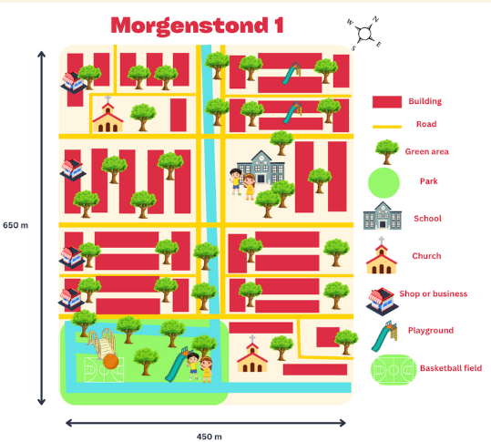*As the main goal of our project was to analyze the biodiversity in the neighborhood, we started the first week with the most obvious task: looking at the biodiversity in the area.* In order to understand what biodiversity is, we will give the description made by the Convention of biological diversity, CBD: Biodiversity is the variability among living organisms from all sources, including, inter alia, terrestrial, marine, and other aquatic ecosystems and the ecological complexes of which they are part; this includes diversity within species, between species and ecosystems. For our project this means that we will look at the number of different kinds of species present in Morgenstond. As none of us are experts in biodiversity, we used the application Obsidentify to identify species in the area. We conducted a ‘BioBlitz’, which is an event in which you try to view as many different species as possible in a certain area in a certain timeframe. For this area we used the area along the greater canal visible in Figure 1 in a timeframe of 45 minutes. In this timeframe we identified around 15 species of plants, 8 species of mosses and lichens, and 3 species of fungi. Furthermore, we identified multiple species of birds and geese. With these data, the hidden biodiversity of the area suddenly became visible. The fields of grass did have more biodiversity than one would think, but the number of species was still very low.

Figure 1, Map of Morgenstond 1

*Spontaneous and informal conversations were what we wanted to have with stakeholders.* This would give us the most honest opinions on biodiversity in the neighborhood. During our day of field work, we found an [evangelical church](https://www.rkparochiedevierevangelisten.nl/emmaus/) which could have been an interesting stakeholder. However, there was a funeral going on, so we found it inappropriate to enter the church and talk with the people there. Our tour continued and we stumbled upon an [evangelical primary school](https://tamarschool.nl/). We decided to go inside and see if there was anyone who could tell us a bit more about biodiversity or biodiversity projects in the neighborhood. However, the person at reception was very hesitant and told us we needed to talk to the director, but that he was very busy. We did encounter a volunteer at the school who was sorting books for the school and was very interested in biodiversity. She didn't know of any projects to increase biodiversity that the school was involved in, but she did enjoy the green spaces in the neighborhood. After visiting the school, we walked to the [Morgenstond church](https://www.morgensterkerkdenhaag.nl/), which is a Christian reformed church. We encountered an elderly man, who was busy removing leaves from the green space surrounding the church. He told us the municipality was responsible for that green space but that they did almost nothing to keep it up. Therefore, he and some other volunteers had taken up keeping up the green spaces. Later, it turned out, this was the only example of social engagement we found. The man also told us that he knew no initiatives in the area to increase biodiversity, other than keeping up the limited green spaces surrounding the church. He went on to comment on the graffiti that was sprayed on the church a couple of days before. The neighborhood police officer was so busy dealing with other issues that there had not yet been a possibility to file charges with the police.

*An important, maybe even the most essential, part of transdisciplinary research is the encountering and engaging of local stakeholders.* As we tried to encounter the school and the church last week, the focus of our encounters for this week was on residents. How do they experience the greenery in the neighborhood? What would they like to be improved? What problems do they experience with biodiversity? Would they themselves like to do something to improve biodiversity? With these and other questions as our guidelines for conversation, we tried to encounter as many residents as possible. We have spoken to a total of 22 residents, both in the park area and the shopping area. It was interesting to see how the location of our encounter influenced the stories told. The residents we spoke to in the shopping area often mentioned that they had a very low interest in green spaces in the city. Most were happy with the nature in the area but had no wish to improve it. Another issue that was mentioned multiple times in the shopping area was safety. In three different encounters people expressed their concerns about the safety of green areas. Two women with children never went to the parks as they did not feel safe there. Residents spoken to in the park area expressed their satisfaction with the green spaces. Most mentioned that the green spaces in the area were nice but they did not think that more was necessary as the area was located next to the Zuiderpark.

*Our search for other stakeholders that wanted to talk to us proved difficult.* We never were able to meet the pastor of the evangelical church and the director of the school did not respond. We also tried to get in contact with the local business association and the [shopping center](https://leyweg.nl/). However, these efforts were in vain. After various attempts, we did not receive word back from any of these stakeholders. The stakeholder we did hear back from was [Staedion](https://www.staedion.nl/). They told us that they were very happy to meet with us and discuss their efforts for a green neighborhood. We were invited to their local offices, not far from the neighborhood we had explored the previous weeks. The employee from Staedion told us they were responsible for the green spaces in between apartment buildings. The green spaces are English lawn style spaces with some trees and a few bushes. This means these areas are not very biodiverse, of course. We inquired as to why Staedion did not make more of an effort to increase biodiversity, for example by planting various flowers. The employee from Staedion found it quite a good idea but explained that that would be very difficult in this neighborhood. There were residents from various backgrounds with various values. If they were to plant some flowers in the green spaces, they would be destroyed by the residents. To have some biodiversity, Staedion planted some vandal proof bushes that would stink if you tried to destroy them. They also grow back very quickly after they are (partially) destroyed. This gives some insight into the social relations in the neighborhood. Besides the green spaces in between the apartment buildings, there are some front gardens at some apartment complexes. Unlike the other green spaces, the front gardens are the responsibility of the residents. Some of these gardens are really well maintained, but others a little less. The upkeep of the gardens often relied on just one person in the building. If they died or moved, there was rarely anyone to pick it up. In that regard, there was no feeling of social responsibility.

**Conclusion**

*The main conclusion of our attempt at transdisciplinary research on the causes of low biodiversity in the Morgenstond area is that a lack of social engagement is central to the low biodiversity.* This lack of social engagement is in our opinion mainly caused by safety issues, difference in ethnicity and a lack of interest and knowledge.

*Our intention was to make this research as transdisciplinary as possible.* To do this, we tried to get in contact with as many stakeholders and actors as possible. We encountered lots of residents and spoke with Staedion, shop owners, the school, and the church. However, we were able to have only one in-depth interview with a stakeholder, namely Staedion. The other stakeholders were not particularly interested in getting into contact with us. What would have been an improvement on the transdisciplinarity of our research is co-production with stakeholders. Sadly, we have not been able to co-produce. We encountered and engaged them but have not co-produced with them. For further research this would improve the relevance of the research.

**Hyperlinks:**

Staedion: <https://www.staedion.nl/>

Tamarschool: <https://tamarschool.nl/>

Shop association: <https://leyweg.nl/>

Morgensterkerk: <https://www.morgensterkerkdenhaag.nl/>

Emmaus: <https://www.rkparochiedevierevangelisten.nl/emmaus/>